Day 4 –> Dynamic Frontend Components Report for Bandage

**Introduction:**

**Tasks:**

**Step #1 (Product Listing)**

**Firsly , my product listing page data is dynamically fetching from sanity**

**And my layout is responsive means friently in all devices.**

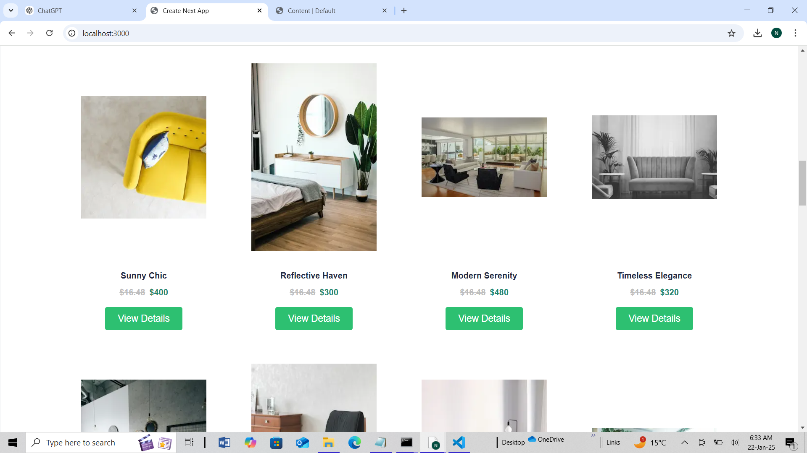

**Step #2 (Product Detailed Page)**

It includes dynamic routing and its data is also dynamically fetching from sanity and I display the add to card button and add to card button is functional. 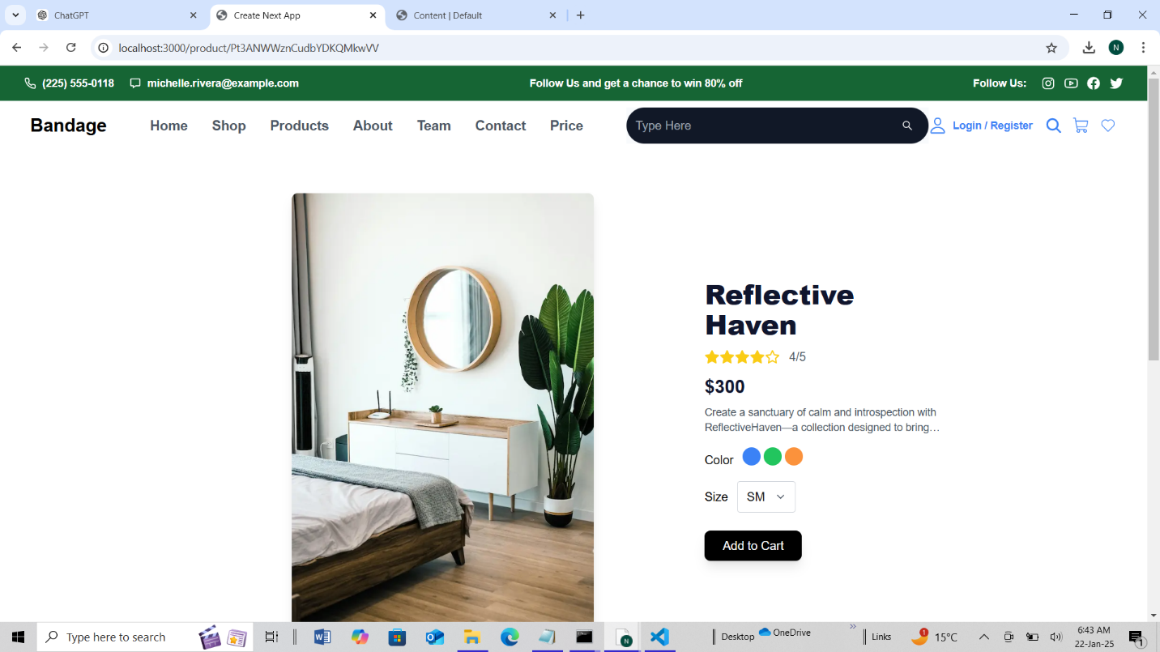

**Step #3 (Search bar and Filter)**

Display the search bar and filters When I type a product name in the search bar input box, I get suggestions for all product names. Once the product name is selected in the input box, I click on the search icon and it takes me to the detailed page of that specific product.

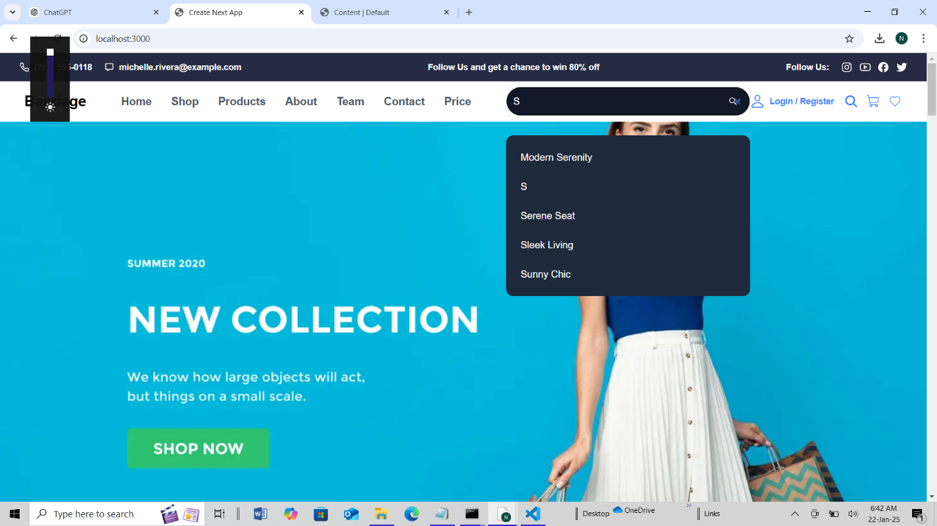

**Step #4 (add to card Functionality)**

**When I click on 'Add to Cart,' the product on the detailed page I am viewing gets added to the cart page.** **And then I receive a message or notification from localhost that my product has been added to my card. Like that**

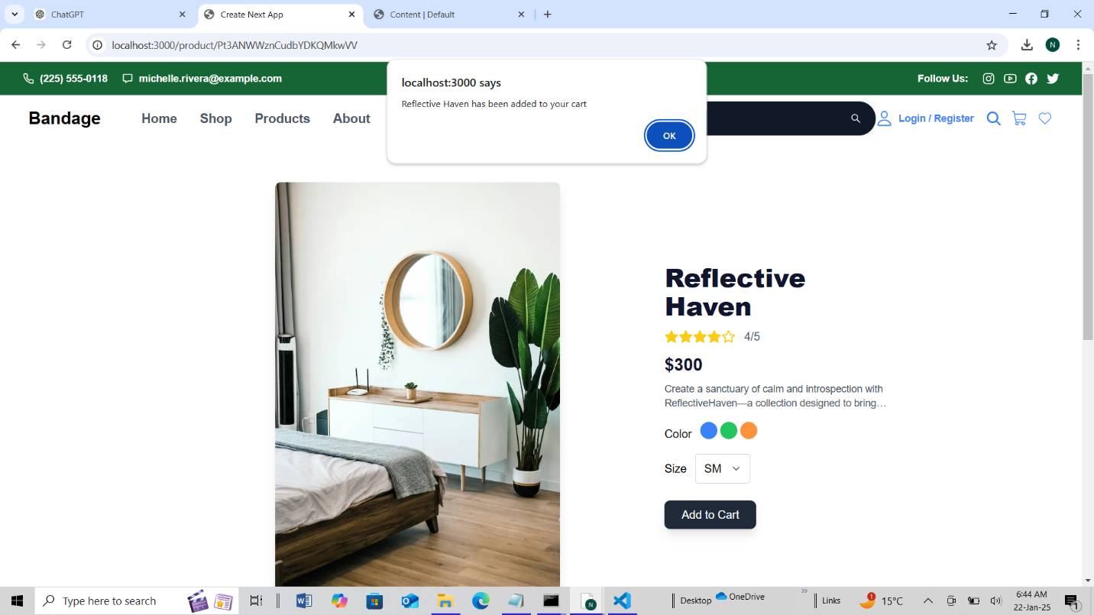

**And when I click on the shopping icon, it takes me to the added product page, where I can increase or decrease the quantity of my product, delete the product, and view the subtotal. There is also a checkout button on the page.**

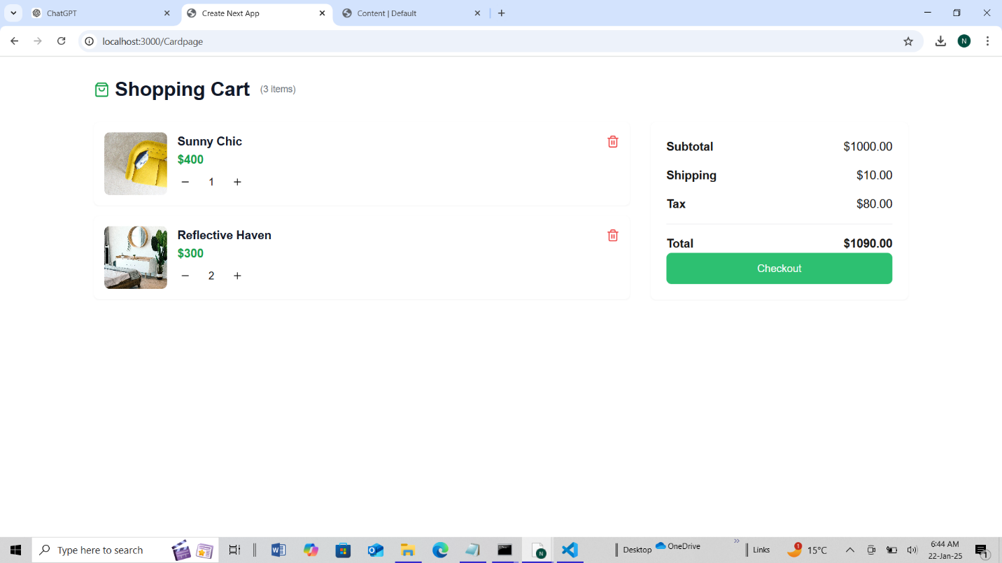

**Step #5 (Checkout Successfully)**

**When I click on the checkout button, it takes me to the shipping form page, which asks for some details, and a 'Continue to Payment' button is also displayed**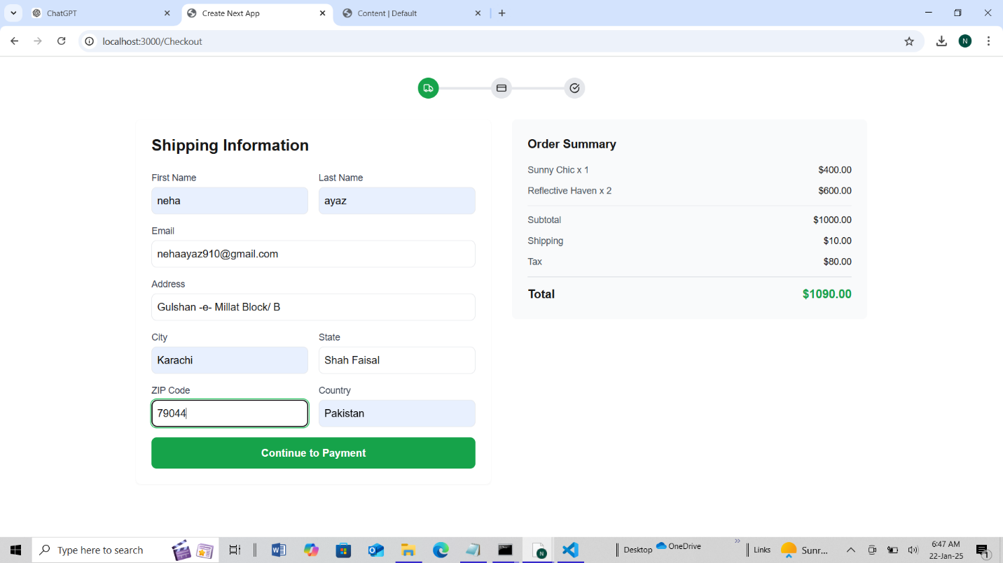

**By clicking on this button, it brings up the payment info, and then your order is placed**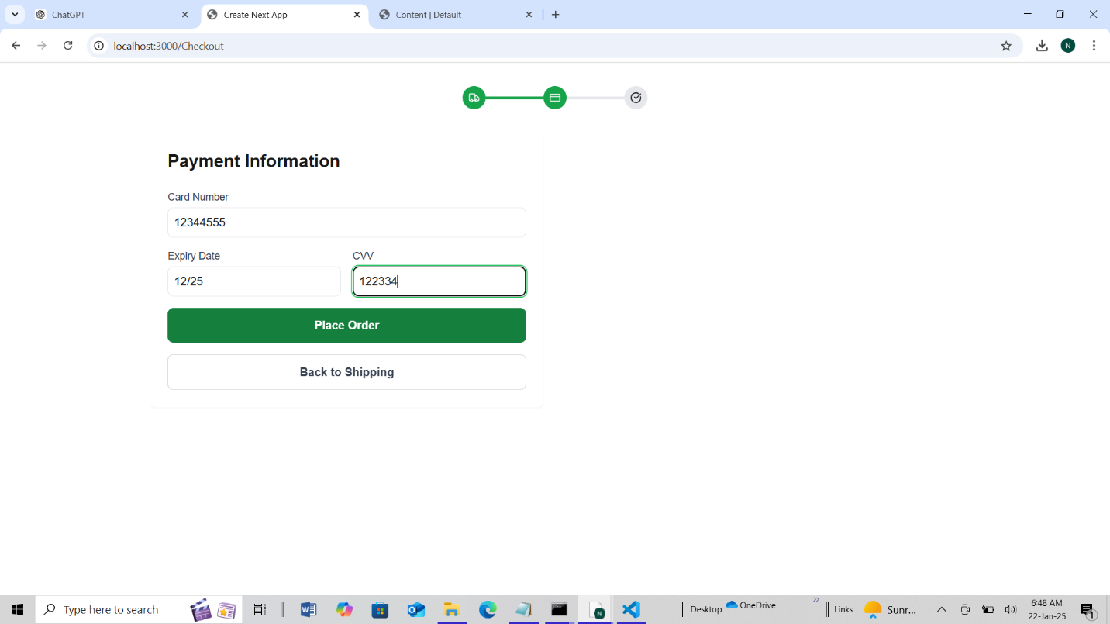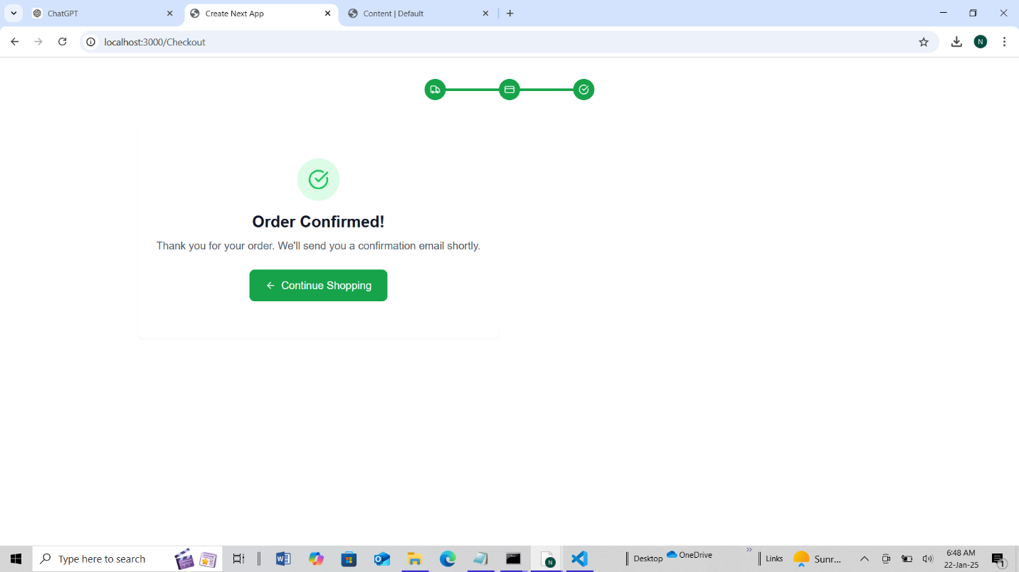

**Check List**

**Self -Validation Check List:**

**Frontend Component Development**

**✔ Dynamic product listing**

**✔ Product detail page functionality**

**✔ Search bar functionality**

**✔ Cart functionality (add/remove items)**

**✔Checkout functionality**

**Styling and Responsiveness**

**✔ Responsive grid layout for product listings**

**✔ Consistent UI design across all pages**

**✔ Mobile responsiveness**

**Code Quality**

**✔ Modular and reusable components**

**✔ Clean and organized code structure**

**✔ Proper use of state management and data binding**

**✔ Optimization for performance and loading speed**

**Documentation and Submission**

**✔ Clear documentation for each component**

**✔ Steps for setting up and running the application**

**✔ Code comments and explanations**

**✔ Submission before the deadline**

**Final Review**

**✔ All functionality tested (products, cart, checkout)**

**✔ UI/UX reviewed for user-friendliness**

**✔ Errors occurred but were resolved.**

**Professional Practices Emphasized**

**✔ Modular and reusable component design**

**✔ State management and dynamic data binding**

**✔ Responsive and user-friendly UI design**

**✔ Through documentation for code and processes**

Author : Neha Ayaz

Summited to Ameen Alam

Bandage Marketplace